PPT Instructions

PPT should contain the following contents
- Title page

Ex.
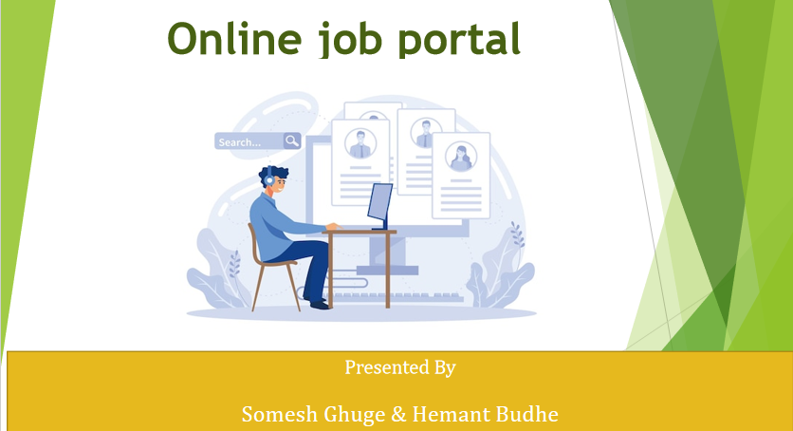

- Index
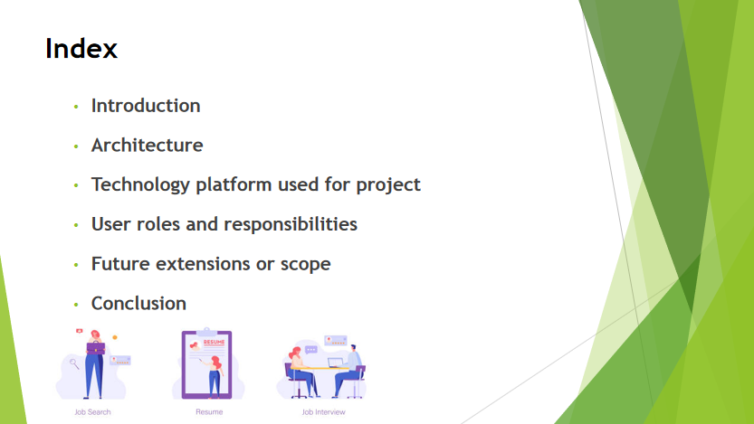
- Introduction
- Technologies
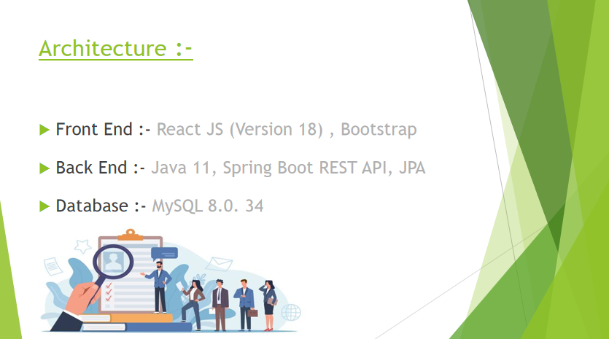

- Users and Roles

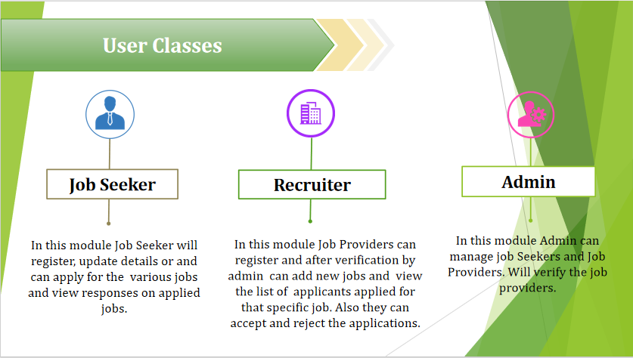

- Use case Diagram of each User

- Future Scope and Extensions
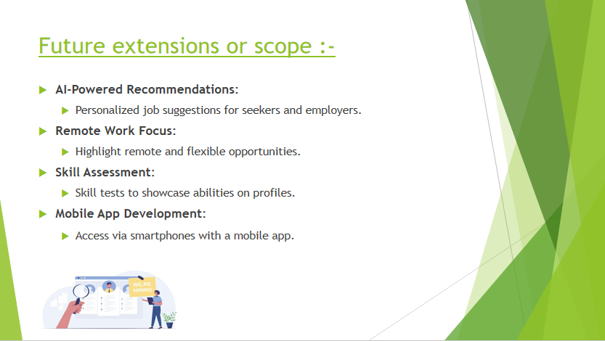

- Screen Shots

- Homepage
- Sign Up page
- Login page
- Change password page
- After an unsuccessful login error page
- Dashboard for Admin
- Screen shots of all functionalities which you have integrated

- Log out page

- Conclusion

